**Ethereal – MYTH**

**MYTH description**

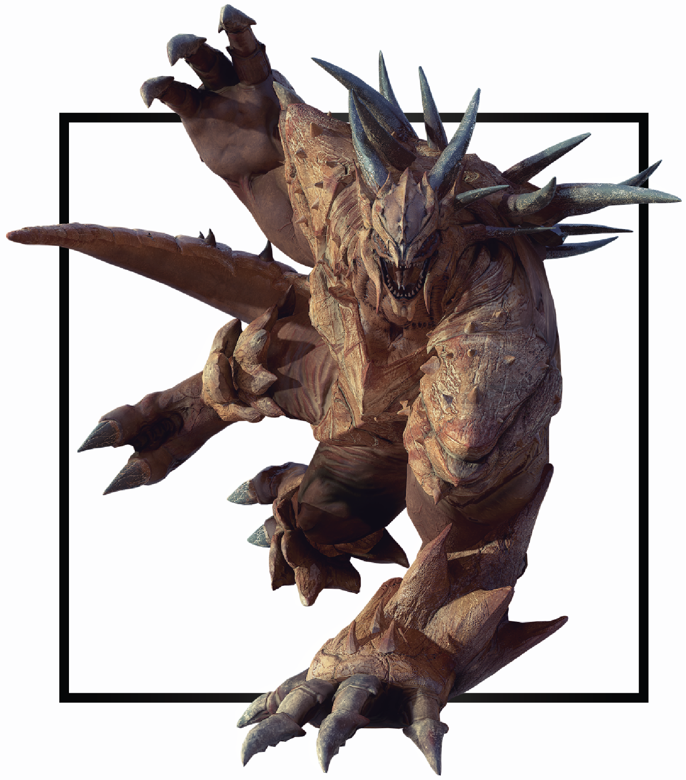

|  |  |
| --- | --- |
| **Name** | Grog’Narc |
| **Title** | Primordial Wrath |
| **Realm** | Edolas |
| **Region** | Desolation Desert |
| **Class** | Berserker |
| **Type** | Melee Physical |
| **Release Date** | Coming Soon |

Since the split of Edolas, deep into the crust of the desert, an enormous creature has been in a deep slumber. Humans full of greed and hungry for power began excavating the mineral-rich mountain range. When they found a cave brimming with priceless ore veins, full of gems and covered in images depicting the wrath of a stone titan they chose to ignore the warnings and looted the cave.

The more precious gems and metals they removed the closer and closer they got to the sleeping Colossus. Suddenly on the day they had found the biggest diamond, a deafening rumble started an earthquake. A giant crack began to split the mountain in half and rock claws burst through the ground. The miners were doomed and Edolas was changed forever.